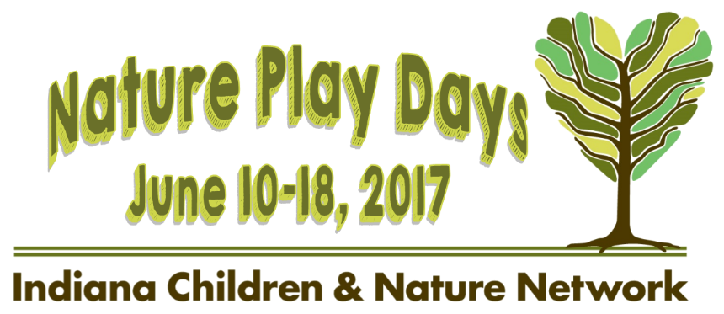
Nature Play Day
Activity Ideas

The purpose of Nature Play Days is to encourage families and children to spend time outdoors and explore nature. Host your Play Day to provide access to the woods, grasslands or a waterway if possible. Perhaps along the way, suggest of a few activities, such as, identifying a good climbing tree or putting nets next to the creek to catch crawdads. Following are some additional ideas.

Water Play
Children love to experiment with water. Encourage hiking in a creek, catching crawdads, looking for invertebrates under rocks. If possible, provide a few buckets and small nets for collecting and viewing critters. Depending on the size of the water body available, consider offering fishing. Build small boats or rafts out of sticks and string

If water is not available, fill up a baby pool and add natural objects for children to experiment with, such as rocks, sands, seeds, sticks etc. Provide cups or watering cans for pouring.

Getting Dirty
Kids need to know dirt! If possible, set up an area where kids can dig. Provide trowels, buckets, and other digging toys. Offer trucks to play with and plastic bugs to hide in the dirt. Add some big rocks. Perhaps offer small pots and seeds for children to plant and take home with them. Or plant some seeds at the location of your Nature Play Day so that kids can come back and visit them!

Mud Play
Mixing dirt and water is always a hit. Find an area where visitors can get their toes or hands in the mud. Encourage kids to make a mud painting on the biggest leaf they can find.

Loose Parts Play
Gather some materials together such as sticks, stumps, rocks, branches, pine boughs, pine cones, and seed pods. Encourage imaginative play such as stacking and building. If the sticks are large, children can make a fort. With smaller items a fairy house can be built. Include animal toys to add to the imaginative play.

Nature Art and Reflection
Encourage children to really look at nature. Lay on the ground and look up into the trees or into the sky. Make binoculars with toilet paper rolls to help them focus on a specific area. Throw a hula-hoop on the ground and see how many different living things you can find. Offer art supplies, such as paints, clay, yarn, sticks, pebbles, glue, pipe cleaners, glitter, and markers, so that children can make their own art creations to represent what they have seen.

The Children of Indiana Nature Park
Teaching kids how to care for the earth? Help them realize their role in protecting our lands and waters by presenting them with their very own piece of a park! The Nature Conservancy along with its partner organizations - the Indiana Department of Education, the Indiana Department of Natural Resources, and Cope Environmental Center - has created a park just for kids. The Children of Indiana Nature Park makes little landowners of K-12 students by giving them a piece of the Park that is their own. This gift of nature is a Signature Project of the Hoosier Bicentennial and is given in the form of a ceremonial Nature IN-Deed. The Children of Indiana Nature Park is in Centerville, Indiana, and the Park’s website has more ideas for ways to connect with nature near you! Visit www.ilovemyland.org to learn more and connect with nature!

More ideas are available on the Resources page of the ICAN website.
ICAN members are here to help you identify activities that will work well for your event. Contact us at npd@indianachildrenandnature.org for free assistance!
Activities that correlate to education standards are also available.

